**ABSTRACT**

A person when he or she does not have proper rest especially a driver, tends to fall asleep causing traffic accidents. For avoiding those accidents we will develop a smart-alert system for driver drowsiness detection using raspberry pi and image processing. These systems take the processing of images captured through a camera which is made to focus on drivers.

The proposed system will analyze the changes taken in face of a driver and then it will be processed through a program in order to detect the drowsiness and send an alert to the driver. The HAAR face detection algorithm takes captured frames of image as input and produces the detected face as output.

**TABLE OF CONTENTS**

**Chapter 1**

**INTRODUCTION**

A person when he or she does not have proper rest especially a driver, tends to fall asleep causing traffic accidents. For avoiding those accidents we will develop a smart-alert system for driver drowsiness detection using raspberry pi and image processing. These systems take the processing of images captured through a camera which is made to focus on drivers. The proposed system will analyze the changes taken in face of a driver and then it will be processed through a program in order to detect the drowsiness and send an alert to the driver. The HAAR face detection algorithm takes captured frames of image as input and produces the detected face as output. Drowsy driving is one of the major causes behind fatal road accidents. Driver fatigue has been the one of the main issue for countless mishaps due to tiredness, tedious, road condition, and unfavorable climate situations. If the drowsiness of the driver can be predicted at initial stages, and if the driver can be alerted of the same, then a number of accidents can be reduced. Drowsiness or sleepiness can be described as a biological state where the body is in transition from awake state to a sleeping state. There are obvious signs that suggest a driver is drowsy, such as

1.Frequently yawning, 2. Inability to keep eyes open, 3. Swaying the head forward

4. Face complexion changes. We are presenting technique to detect driver drowsiness using of open CV, raspberry pi and image processing. A camera monitors the driver’s eye blinking, eye closure, face detection, head posture Yawning detection is based on the changes in the mouth geometric features. Drowsiness is intermediate stage between wakefulness and sleep that has been defined as the state of progressive impaired awareness associate with the desire or inclination to sleep.

In real time driver drowsiness system using Image Processing, capturing drivers eye state using computer vision based drowsiness detection system have been done by analyzing the interval of eye closure and developing an algorithm to detect driver’s drowsiness in advance and to warn the drivers by in vehicles alarm.

The HAAR classifier Cascade files inbuilt on Open CV include different classifiers for face detection and eyes detection.

HAAR cascade is a well-known robust feature-based algorithm that can detect the face image efficiently.

If the percentage of eye closure (PERCLOS) is defined as the proportion of time for which the eyelid remains closed, more than 70–80% within a predefined time period, then the level of drowsiness will be detected based on the PERCLOS threshold value.

The face detection and open eye detection have been carried out on each frame of the driver’s facial image acquired from the camera.

LBPH(local binary pattern histogram) is a face-recognition algorithm it is used to recognize the face a person.

Circular Hough transformation is used here to find shape of eyes.

The main advantages of the Hough transform technique is that it is liberal to gaps in feature boundary description and is relatively unaffected by image noise, unlike edge detectors.

Presently days, street accidents are serious issue and its rate increments every year. The serious issue behind the street accidents are imprudent driving, non utilization of security measures and advances like Adaptive Cruise control and wellbeing Airbags, sluggishness of vehicle driver because of medium-term drive, outstanding task at hand, ailment like unexpected heart assault and the significant one is if the driver is alcoholic.

To maintain a strategic distance from street accidents numerous advancements are being built up, the one which take a shot at well being of vehicle and driver is " Adaptive Cruise Control ", this framework has inbuilt RADAR that gives point by point data to the rider about the vehicle speed moving before it, and if his speed gets lower, Cruise Control system controls the speed of host vehicle.

To stay away from accidents caused because of sluggishness of vehicle driver , various advancements are created.

First one depends on vehicle, in which it constantly observed guiding wheel position, path position and weight on increasing speed pedal.

Second one depends on behavioral, in which it persistently checked flickering recurrence of eye, eye conclusion and head present.

There are 3 primary factors because of which driver gets weakness. These are rest, remaining task at hand, rest time of day, body ailment and physical condition. As per our body clock, we can do greatest work amid day time and take (rest) amid night. Assume the vehicle driver works amid day and ventures a vehicle amid night without taking rest at that point, human body clock influences on him.

Next is the work. The sort of work (light/overwhelming) likewise influences on driver amid night. As a result of overwhelming work, he progresses toward becoming weakness and needs rest. In the event that he doesn't take legitimate rest and voyages, at that point driver winds up tired.

The restorative explanation behind tiredness is likewise unique. The languor of a vehicle driver relies upon the discharges in the body. The body emissions additionally influence the exercises of an individual. There are two sorts of exercises in our body to be specific thoughtful and parasympathetic. Thoughtful exercises are constrained by adrenalin discharge. What's more, parasympathetic exercises are constrained by acetylcholine emission. At the point when adrenalin emission in body is most extreme around then, the opening territory of eye is greatest methods the individual is alert. Essentially, when acetylcholine emission is greatest around then, the opening territory of eye is least methods the individual is languid. At whatever point, the driver gets weariness around then, the acetylcholine discharge in body is most extreme, because of this iris some portion of eye is contracted.

**METHODOLOGY**

There are different methodologies developed for detecting the driver drowsiness and also preventing the road accidents.

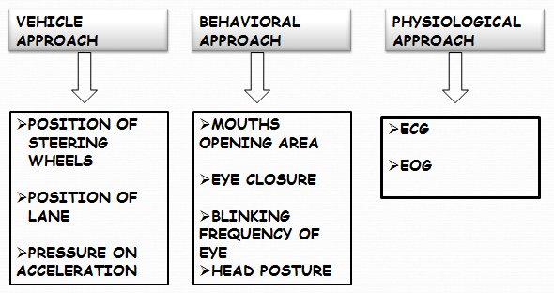

**Vehicle based approach**-It is one of the techniques to find out driver drowsiness. The technique continuously monitored position of lane, position of steering and foot pressure on accelerator. If it crosses the threshold values then it indicate that the driver gets drowsy.

**Physiological based approach-**In this technique, we continuously observe pulse rate, heart rate and brain activity information. ECG is used to calculate the variation in heart rate and also detect different conditions for drowsiness. EEG is used to calculate the different electrical activities of brain. In order to determine the brain activities, electrodes are placed around the scalp of the car driver. These electric chords finds the voltages produced in the brain. This voltages contain three frequencies related to alpha , beta and gamma waves. These frequencies can be further processed to calculate drowsiness and different sleep stages.

**Behavioral based approach**-This approach includes yawning (opening area of mouth), eye closure, eye blinking frequency and head pose. This can be done by placing camera in front of the car driver. The camera continuously captures images of the car driver. The car driver’s image is further processed for detecting drowsiness of the driver.

**METHODOLOGY OF IMPLEMENTATION:**

Practically, Physiological based approach is not suitable for drowsiness detection. It is unsafe for driver and environmental conditions also affected the electrode. Also Vehicle based approach is not suitable. Because vehicle based approach is based on monitoring the driving pattern of the car. But the problem is, it is difficult to determine when the driver is in micro sleep or in a deep sleep? This situation is dangerous for the driver and also car. Hence we are using Behavioral based approach in our project.

Because of discharge of adrenalin and acetylcholine, the zone of opening eye changes. Fundamentally, our eye developments are constrained by six muscles in particular prevalent rectus, second rate rectus, sidelong rectus, average rectus, predominant sideways and sub-par slanted. What's more, this six muscles action is constrained by the nerve. Because of the developments of these muscles, understudy some portion of eye is enlarged or tightened and iris some portion of eye is likewise choked or widened. So as to screen the eye developments alongside the iris and understudy territory, we need to utilize a camera for catching the constant pictures of eye.

**HAAR CASCADE**

Haar Cascade is based on the concept of features which are

proposed by Paul Viola and Michael Jones in their paper “Rapid Object Detection using a Boosted Cascade of Simple Features” in 2001. It is a machine learning based approach where a cascade function is trained from a lot of positive and negative images. It can be used to detect objects from an image or a video.

This algorithm comprises of four stages:

1. Haar Feature Selection
2. Creating Integral Images
3. Adaboost Training
4. Cascading Classifiers

Though Haar Cascade is used for detecting almost all objects, it is popular for detecting faces in images. Adaboost which both selects the best features and trains the classifiers that use them. This algorithm constructs a “strong” classifier as a linear combination of weighted simple “weak” classifiers.

A Haar feature considers adjacent rectangular regions at a specific location in a detection window, sums up the intensities of the pixels in each region and calculates the difference between these sums. During the detection phase, a window of the target size is moved over the input image, and for each subsection of the image and Haar features are calculated. This difference is then compared to a learned threshold that separates non-objects from objects. Because each Haar feature is only a "weak classifier" i.e. its detection quality is slightly better than random guessing and a large number of Haar features are necessary to describe an object with sufficient accuracy and are therefore they are organized into **cascade classifiers** to form a strong classifier.

**Haar like features:**

  is an eminent image processing technique utilized in recognizing an object, Haar wavelets are the principles behind this framework and were utilized in the primary continuous face finder.

This work on adjacent rectangular/square regions on the object, totals up the densities of pixels at areas and figures the negative and positive regions.

In this rectangle areas considered at a picture adjacently in a identification window, sums up the pixel strengths in every local regions and figures the distinction among these entities, which is then made use to categorize sub-sections of a picture. For instance, let us take human face, eyes region is darker than the region of cheeks. Consequently a typical Haar feature for face discovery rely on set of two square shapes over the eye and the cheek region.

A classifier organized by large number of haar features to reveal an object very precisely is done.

Due to use of integral images, a haar feature computation time is very consistent and thus possess high computation speed over other features.

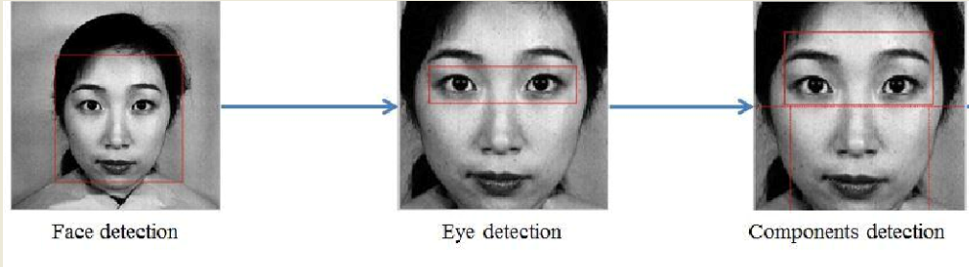

**Haar-cascade Detection in OpenCV**

OpenCV can be used when need to set our very own classifier for any article like vehicle, planes etc. OpenCV contains numerous pre-prepared classifiers for face, eyes, smile and so on. Those XML documents are put away in opencv/data/haarcascades/folder.

First we have to load the required XML classifiers. At that point load our input information picture (or video) in grayscale mode.

Now we find the faces in the image. If faces are found, it returns the positions of detected faces as Rect(x,y,w,h). Once we get these locations, we can create a ROI for the face and apply eye detection on this ROI .

**DIGITAL IMAGE PROCESSING**

The term digital image processing generally refers to processing of a two dimensional picture by a digital computer. In a broader context, it implies digital processing of any two- dimensional data. A digital image is an array of real numbers represented by a finite number of bits. The principle advantage of Digital Image Processing methods is its versatility, repeatability and the preservation of original data precision.

**Pixel:**

Pixel is the smallest element of an image. Each pixel corresponds to any one value. In an 8-bit gray scale image, the value of the pixel between 0 and 255. The values of a pixel at any point correspond to the intensity of the light photons striking at that point. Each pixel stores a value proportional to the light intensity at that particular location.

**Digital image:**

A digital image is nothing more than data numbers indicating variations of red, green,and blue at a particular location on a grid of pixels.

**Gray level:**

The value of the pixel at any point denotes the intensity of image at that location, and that is also known as gray level. Generally to convert an image to gray scale, the equation that was used previously is : Grayscale = (Red + Green + Blue / 3).But as red has more wavelength we use the equation:

**Grayscale = ((0.3 * R) + (0.59 * G) + (0.11 * B)). -- Eq: (1)**

Now we find the faces in the image. If faces are found, it returns the positions of detected faces as Rect(x,y,w,h). Once we get these locations, we can create a ROI for the face and apply eye detection on this ROI .

## PERCLOS

PERcentage of eye CLOSure (PERCLOS) is defined as the proportion of time for which the eyelid remains closed more than 70-80% within a predefined time period. Level of drowsiness can be judged based on the PERCLOS threshold value.

Perclos is a drowsy detection measure used to calculate the percentage of eyelid closure over the pupil over time. It is used by various real-time drowsiness detection systems and is able to yield effective results. Developers use different set of hardware to capture the closure movement of the eyelids for developing the accuracy of the system. This project uses camera mounted on the dashboard of the vehicle and is set up in such a way that the driver is visible on the camera. This helps in better detection of the face and calculating the eyelid closure frequency using Perclos measure. A total of six points are marked for each eye and the Euclidean distance is calculated for each eye. The eye aspect ratio for each eye are then calculated for average eye-aspect ratio.

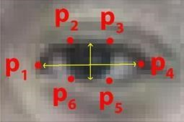

### Fig Perclos algorithm

**ear = (A + B) / (2.0 * C)**

where

1. is the distance between the 2-points (p2 and p6)
2. is the distance between the 2-points (p3 and p5)

### C is the distance between 2-points (p1 and p4)

The number of frames are 20 for this system with a threshold value of 0.25. Based on this value, the alarm is made to sound. If the eye aspect ratio is less than the threshold value for given number of frames then it will detect the driver as drowsy and alert is given through an alarm.

**CNN:**

**SVM:**

**ALGORITHM:**

The different steps involved in algorithm for Raspberry-pi model are as follow.

(a) Images are caught To peruse a picture from the Raspberry-pi camera; we first open the camera inside the Open CV utilizing the inbuilt function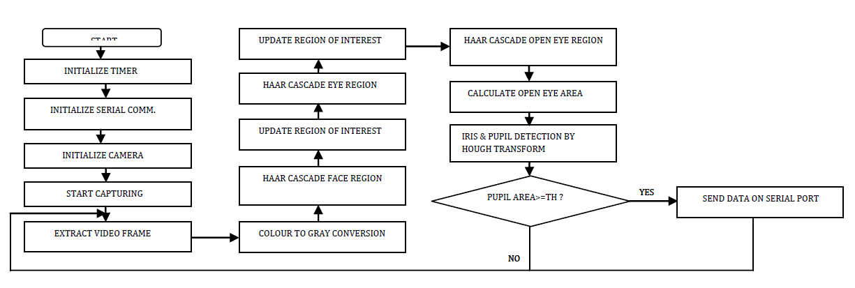

Warning Signal

b) camera frames are extracted from after opening the camera using above function. It begins catching the video for processing purpose. We need image, hence use function **Success, frame=cap. read ( ),** This function is to read a frame from the camera. In order to display the image use function **Cv2.imshow (frame).** This function makes sure that the image in a window is properly getting.

c) Image Thresholding- In our image, we need to find discover the region in which pupil is located. So the color image must be changed over to Binary image. Also locate eye, pupil and iris in the image. Open CV has in build function to be specific **in Range ( ).** The function alters the color of the required part (eye, pupil and iris) which we required. The function changes the Hue, Saturation and Value of the required part. This Hue, Saturation and Value fluctuate in various range from low an incentive to high esteem. These two values of Hue, Saturation and Value are used for image Thresholding process. Thresholder variable contains another image, but unlike the original frame, it is black and white.

Picture Thresholding-In our picture, we need to discover the region in which understudy is found. So the shading picture must be changed over to Binary picture. Additionally find eye, student and iris in the picture. Open CV has in manufacture work to be specific in Range ( ). The capacity alters the shade of the required part (eye, understudy and iris) which we required. The capacity changes the Hue, Saturation and Value of the required part. This Hue, Saturation and Value fluctuate in various range from low an incentive to high esteem. These two estimations of Hue, Saturation and Value are utilized for picture Thresholding process. Img Thresholded variable contains another picture, however not at all like the first edge, it is high contrast.

d) Haar-like features arw 2-D Haar functions. These Haar functions are used to encode a specific object in given image. Haar functions have rectangular regions, which are grouped in a template. Haar features detect human faces in photographs.

Haar features meant for accuracy and quicker response than other face detectors. The result of Haar feature function consists of K rectangles.

e) After detecting the eye region the Hough transform is used to detect the eye opening and closing and decision is made when eye closure exceeds predetermined threshold

**FLOW DIAGRAM:**

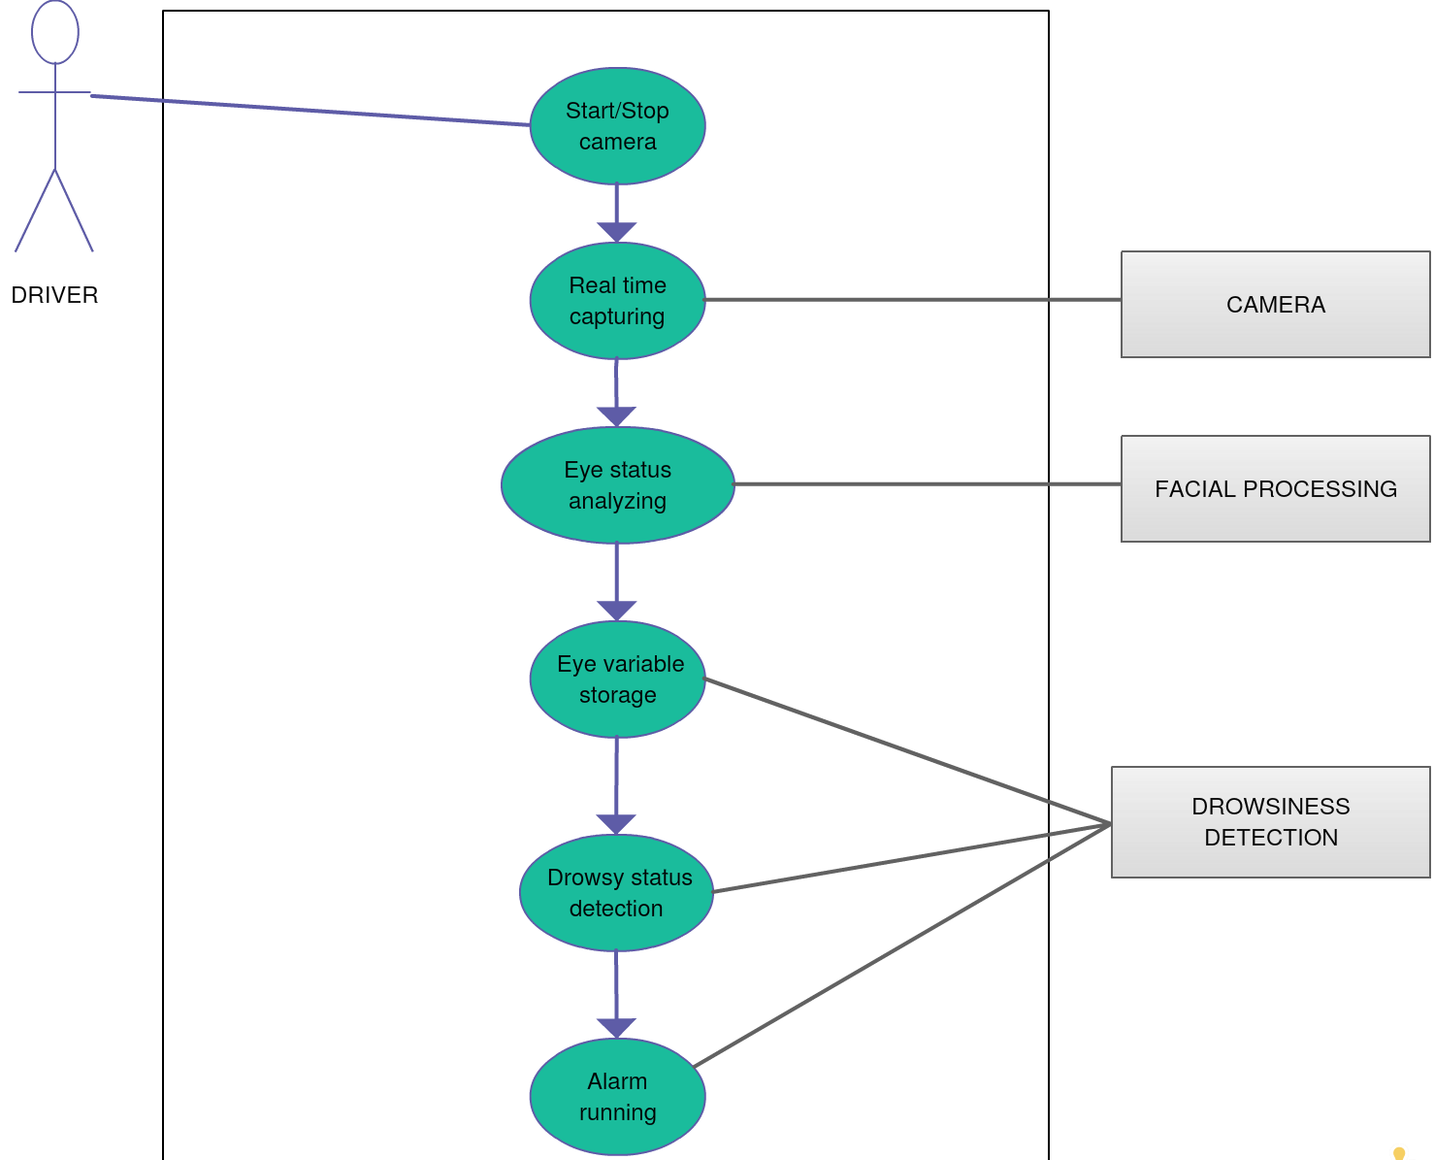

**ARCHITECHTURE:**

**Face Detection**:

This module takes input from the camera and tries to detect a face in the video input. The detection of the face is achieved through the Haar classifiers mainly, the **Frontal face cascade classifier**. The face is detected in a rectangle format and converted to grayscale image and stored in the memory which can be used for training the model.

**Eye Detection**:

Since the model works on building a detection system for drowsiness we need to focus on the eyes to detect drowsiness. The eyes are detected through the video input by implementing a haar classifier namely **Haar Cascade Eye Classifier**. The eyes are detected in rectangular formats **Face Tracking**:

Due to the real-time nature of the project, we need to track the faces continuously for any form of distraction. Hence the faces are continuously detected during the entire time

**Eye Tracking**:

The input to this module is taken from the previous module. The eyes state is determined through Perclos algorithm.

**Drowsiness detection:**

In the previous module the frequency is calculated and if it remains 0 for a longer period then the driver is alerted for the drowsiness through an alert from the system

**Distraction detection:**

In the face tracking module the face of the driver is continuously monitored for any frequent movements or the long gaze of the eyes without any blinks which can be treated as lack of concentration of the driver and is alerted by the system for distraction.

**LITERATURE SURVEY**

**DROWSINESS DETECTION THROUGH REGION OF INTEREST:**

* Region of interest (ROI) can detect a driver’s face. As can be seen in the blue rectangle is the region of interest.
* The way to create an ROI area is to first obtain the green rectangle area from the Haar Cascade Classifier in the first frame, which includes height, width.
* The rectangle is scaled up to create region of interest. There are several steps to calculate the ROI area and to calculate ROI for each and every region of interest [1].

**DETECTION OF DROWSINESS THROUGH LBPH:**

* In this algorithm the faces are detected by using local binary patterns histograms (LBPH).
* The first computational step in lbph is to create an intermediate images that describes the original image in a binary format.
* The image is converted into matrix form and need to take a central value of the matrix to be used as and threshold value.
* Threshold value is used to define neighbouring values which can be set to either 0 or 1.
* The values which are 1 in the matrix form are to be considered and the remaining values are discarded. The values represent each pixel.
* Through this the region of face can be detected. [2]

**BEHAVIOURAL BASED TECHNIQUES**

**EYE TRACKING AND DYNAMIC TEMPLATE MATCHING**

* To avoid road accidents, real time driver fatigue detection system based on vision is proposed.
* System detects the face of driver from the input images using HIS(hue saturation ,and intensity color model.
* Sobel edge operator is used to locate the eyes positions and gets the images of eye as the dynamic template for the tracking of eye. Then the obtained images are converted to HSI colour model to decide that whether the eyes are close or open to judge the drowsiness of driver.
* The experiments use four test videos for the tracking of eyes and face detection. The proposed system is compared with the labelled data which is annotated by the experts. The average correct rate of proposed system reaches up to 99.01 % and the precision to 88.90 %.[3]

**MOUTH AND YAWNING ANALYSIS**

* Fatigue is the major reason for road accidents. To avoid the issue, they develop the driver fatigue detection system based on mouth and yawning analysis.
* Firstly, the system locates and tracks the mouth of a driver using cascade of classifier training and mouth detection from the input images. Then, the images of mouth and yawning are trained using SVM.
* SVM is used to classify the regions of mouth to detects the yawning and alerts the fatigue.
* For experiment, they collect some videos and select 20 yawning images and more than 100 normal videos as dataset. The results show that the proposed system gives better results as compared to the system using geometric features. The proposed system detects yawning, alerts the fatigue earlier and facilitates to make the driver safe. [4]

**FACIAL EXPRESSIONS METHOD**

* Laboratory condition using Finite Element Analysis is used by the researchers which is a complex system that contains the database of facial expression as a template and detect the drowsiness on the basis of results from database.
* The hardware-based Driver Drowsiness Detection system based on facial expressions. The hardware system uses infrared light as it has giving many benefits like ease of use, independent of lightning conditions of environment.
* The system firstly uses the technique of background subtraction to determines the face region from the input images. Then using horizontal projection and template matching, facial expressions are obtained. After that in the tracking phase, elements found earlier are followed up using template matching and then investigates the incidence of sleepiness using the determination of facial states from the changes of the facial components.
* Changing in the three main elements such as eye brow rising, yawning and eye closure for the certain period are taken as the initial indications for drowsiness and the system generates the alert.
* The experiment is performed in the real driving scenario. For testing, images are acquired by the webcam under different conditions of lighting and from different people.  
   The results investigate that the system produces appropriate response in the presence of beard or glasses and mustacho on the face of driver.[5]

**YAWNING EXTRACTION METHOD**

* Fatigue or drowsiness is the major reason for road accidents. To prevent the issue, they proposed the efficient system for monitoring the driver fatigue using Yawning extraction.
* Firstly, face region is obtained from the images using Support Vector Machine (SVM)technique to reduce the edge required cost.
* The proposed method is used to localize the mouth, detection technique is used to detects facial edges, then compute vertical projection on the lower half face to detect the right and left region boundaries and then compute the horizontal projection on the resulting region to detect the upper and lower limit of mouth and mouth localized region is obtained.
* Finally, to detect the yawning, Circular Hough Transform (CHT) is executed on the images of mouth region to identify the wide-open mouth. If the system finds notable number of continuous frames where the mouth is widely open, system generates the alert.
* The results are compared with the other edge detectors like Sobel, Prewitt, Roberts, Canny. The experiment uses 6 videos representing real driving conditions and results are presented in the form of confusion matrix. The proposed method achieves 98% accuracy and outperforms all other edge detection techniques.[6]

**EYE CLOSURE AND HEAD POSTURES METHOD**

* The Drowsy Driver Detection using Eye Closure and Head postures. Firstly, video is captured using webcam and for each frame of video, following operations are performed. To detect the ROI (face and eyes), viola-jones method is used.
* The face is partitioned in to three areas and the top one presenting the eye area is browsed by the Haar classifier. Then to detect the eye state, Wavelet Network based on neural network is used to train the images then the coefficients learning images is compared with the coefficients of the testing images and tells which class it belongs.

.

* When the closed eye is identified in the frames then the eye closure duration is calculated, if the value exceeds the predefined time then the drowsiness state is detected.
* Then the developed system estimates the head movements which are: left, right, forward, backward inclination and left or right rotation. The captured video is segmented into frames and extract the images of head and determines the coordinates of image. Then the images are compared to determine the inclined state of head and same case with other head postures.
* The system combines the eye closure duration and head posture estimation to measure the drowsiness. To evaluate the system, experiment is performed on 10 volunteers in various situations. And results show that the systems achieve the accuracy of 80%. [7]

**EYE BLINK DETECTION METHOD**

* The Driver Drowsiness System based on non-intrusive machine-based concepts.
* The system consists of a web camera which is placed in front of the driver. Online videos as well as saved videos for simulation purposed are considered. Firstly, camera records the facial expressions and head movements of the driver.
* Then the video is converted into frames and each frame is processed one by one. Face is detected from frames using Viola-jones algorithm.
* Then the required features like eyes, mouth and head from face are extracted using cascade classifier. Region of interest on face is indicated by rectangles.
* The main attribute of detecting drowsiness is eyes blinking, varies from 12 to19 per minute normally and indicates the drowsiness if the frequency is less than the normal range. Instead of calculating eye blinking, average drowsiness is calculated. The detected eye is equivalent to zero (closed eye) and non-zero values are indicated as partially or fully open eyes. The equation (2) is used to calculate the average. [8]

**AUTOMATIC DETECTION OF DRIVER FATIGUE**

* To address the issue of drivers’ fatigue, an online detection of drivers’ fatigue using the Steering Wheel Angles (SWA) and Yaw Angles (YA) information in the real driving conditions is proposed.
* The system firstly investigates the operation features of SWA and YA in the different states of fatigue, after that calculates the ApEn features on time series of shot sliding window, then using the dynamic time series of non-linear feature construction theory and taking features of fatigue as input, designs a 2-6-6-3 multi-level Back Propagation (BP) neural network classifier to deter- mine the fatigue detection.
* For empirical analysis, 15 hours long experiment is performed in real road conditions. The experts evaluated the retrieved data and categorized in three levels of fatigue: drowsy, very drowsy, and awake.
* the experiment achieves the average accuracy of 88.02% in fatigue detection and valuable for the engineering applications.[9]

**DROWSINESS DETECTION THROUGH PHYSIOLOGICAL APPROACH**

* Physiological measures have much of the time been utilized for drowsiness discovery as they can give an immediate and objective measure.
* Conceivable measures are Electro
* encephalography (EEG) eyelid closure, movements of eye, heart rate, size of pupil, skin conductance and creation of the cortical. Among these procedures, the systems that are best, in light of precision are the ones in view of physiological experience of human. There are two ways for implementing this procedure. Measurement of changes in physiological signs for example, waves of human brain, blinking of eyes and heart rate; and physical changes measurement for example, drooping stance, leaning of the head of driver and the open/close conditions of the eyes. [10]

**RESULT:**

The Raspberry-PI successfully detected fatigueless or drowsy drivers by using face detection and eye edge detection. Here, efficient algorithms like Haar features and Hough transform are used for efficient and quick response. This drowsiness detection technique can be deployed practically in any vehicle. The haar features are applied to the image and blink frequency is counted using the perclos algorithm. If the value remains 0 for some amount of time, then it detects that the driver is sleepy and starts an alarm.